Javier Jesús Macossay-Hernández EE 348L

February 24, 2016

**Prelab #5**

Exercise

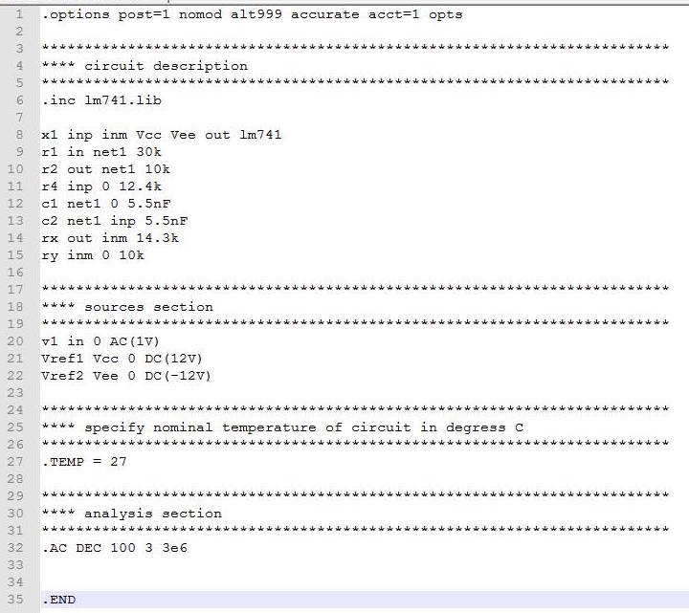

Netlist

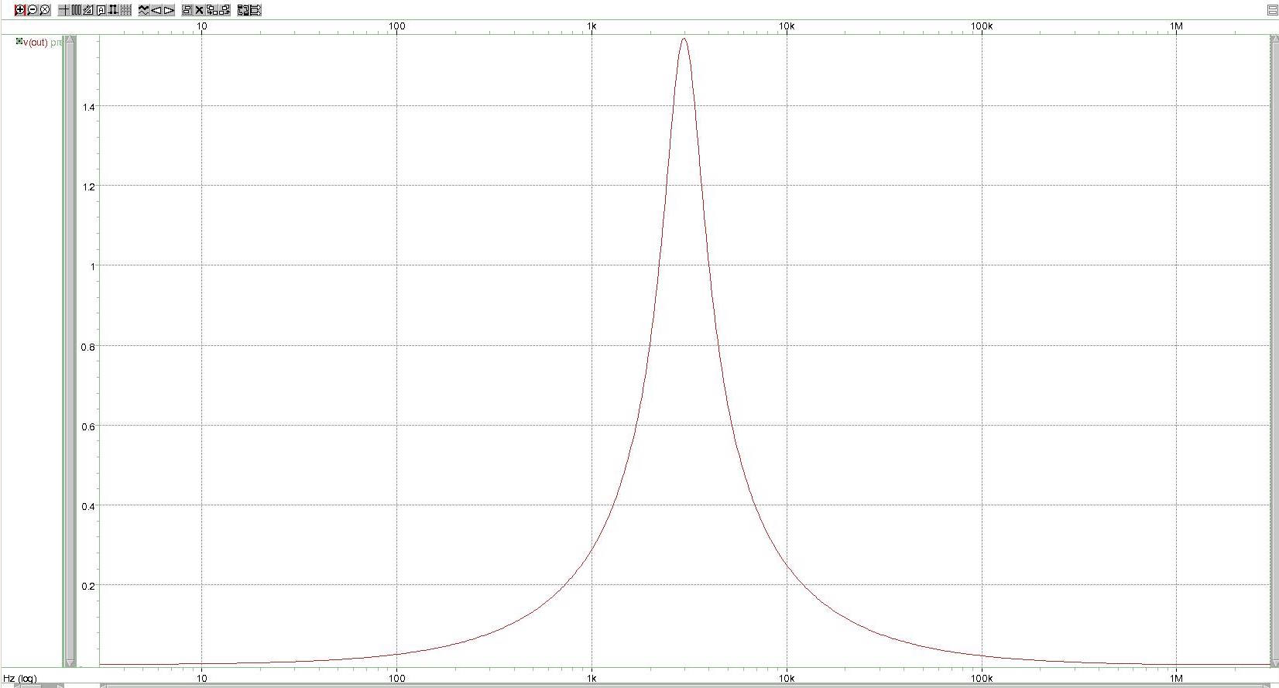

Band-Pass Filter